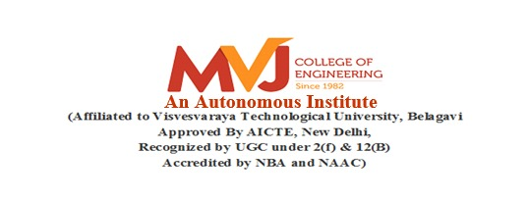

**Department of Computer Science and Engineering**

#### *Certificate*

This is to certify that the mini project entitled **"COURIER MANAGEMENT SYSTEM”** is a bonafide work carried out by **CHIRAG D (1MJ19CS716)** a student of MVJ College of Engineering in partial fulfillment for the award of degree of Bachelor of Engineering in Computer Science & Engineering of the Visvesvaraya Technological University, Belagavi during the year 2021-22. It is certified that all the corrections/suggestions indicated for Internal Assessment have been incorporated in the Report. The mini Project Report has been approved as it satisfies the academic requirements in respect of Project work prescribed for the said degree.

|  |  |  |
| --- | --- | --- |
| **Signature of the Guide** |  | **Signature of the HOD** |
|  |  |  |

**Signature of the Examiners**

***............................................ ...........................................***

**Internal External**